JPO 152 Additional Physics
Class Test 1B : 1 March 2013
Surname: Student Number: Total: /20
Question 1 [4]
Describe (in three words or less) the relationship between vectors that means they have the following mathematical properties:
- $\vec{a}+\vec{b}=\vec{c}$ and $a^{2}+b^{2}=c^{2}$ (2)
Perpendicular

- $\vec{a}∙\vec{b}=ab$ and $\vec{a}≠0$ and $\vec{b}≠0$ (2)
Parallel

Question 2 [6]
Consider the following two vectors:
$\vec{a}=4.0\hat{i}-3.0\hat{j}$ $\vec{b}=6.0\hat{i}+8.0\hat{j}$
Calculate $\vec{a}+\vec{b}$ and $\vec{a}-\vec{b}$ and represent this vector in direction magnitude notation
$$\vec{a}+\vec{b}=\left(4.0+6.0\right)\hat{i}+\left(8.0-3.0\right)\hat{j}=10\hat{i}+5.0\hat{j}$$
$$\left|\vec{a}+\vec{b}\right|=\sqrt{{10}^{2}+5^{2}}=\sqrt{125}=11.2$$
$$\tan{θ}=\frac{5}{10}⇒θ=\tan^{-1}\left(\frac{5}{10}\right)=26.6°$$
11.2m at 26.6° counter clockwise to positive x axis
$$\vec{a}-\vec{b}=\left(4.0-6.0\right)\hat{i}+\left(-3.0-8.0\right)\hat{j}=-2.0\hat{i}-11\hat{j}$$
$$\left|\vec{a}+\vec{b}\right|=\sqrt{{(-2)}^{2}+{(-11)}^{2}}=\sqrt{125}=11.2$$
$$\tan{θ}=\frac{2}{11}⇒θ=\tan^{-1}\left(\frac{2}{11}\right)=10.3°$$
11.2m at 259.7° counter clockwise to positive x axis

Question 3 [10]
A sample of ice is placed in a thermally isolated container with a sample of water and the system is allowed to come to thermal equilibrium. The graph below shows the temperature of the two samples as a function of time
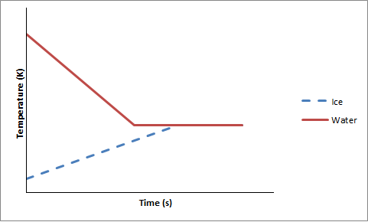
- Is equilibrium temperature above, below or at the freezing point of water? Explain(3)
At freezing point. Thermal equilibrium (point where graphs intersect) occurs when the water is undergoing a phase change (horizontal section on graph for water indicates a phase change)

- Does the ice fully melt, partly melt or undergo no melting? Explain (3)
No melting. The ice only increases temperature before thermal equilibrium is reached (no horizontal section on the graph for ice)

- If the sample of ice originally has a mass of 100 g at -30°C and the sample of water 25 g at 20 °C, how much water is converted to ice? (4)
$$Q_{ice}+Q_{water}=0$$
$$m_{ice}c_{ice}∆T_{ice}+m_{water}c_{water}∆T_{water}-m_{transformed}L_{f}=0$$
$$m_{transformed}=\frac{-m_{ice}c_{ice}∆T_{ice}-m_{water}c_{water}∆T_{water}}{-L_{f}}=\frac{-0.1\left(2220\right)\left(0-\left(-30\right)\right)-0.025\left(4187\right)\left(0-20\right)}{-333000}$$
$$=14g$$

Formula Sheet
$$\vec{a}∙\vec{b}=ab\cos{θ}=a_{x}b_{x}+a_{y}b_{y}+a_{z}b_{z}$$
$∆l=lα∆T$ $∆V=Vβ∆T$
$Q=Lm$ $Q=mc∆T$

